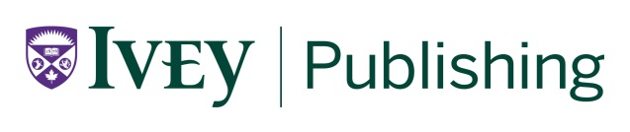

9B18B018

DANONE: ADOPTING INTEGRATED REPORTING OR NOT? (B)

Ken Mark wrote this case under the supervision of Professors Diane-Laure Arjaliès, Delphine Gibassier, and Michelle Rodrigue solely to provide material for class discussion. The authors do not intend to illustrate either effective or ineffective handling of a managerial situation. The authors may have disguised certain names and other identifying information to protect confidentiality.

*This publication may not be transmitted, photocopied, digitized or otherwise reproduced in any form or by any means without the permission of the copyright holder. Reproduction of this material is not covered under authorization by any reproduction rights organization. To order copies or request permission to reproduce materials, contact Ivey Publishing, Ivey Business School, Western University, London, Ontario, Canada, N6G 0N1; (t) 519.661.3208; (e)* [*cases@ivey.ca*](mailto:cases@ivey.ca)*;* [*www.iveycases.com*](http://www.iveycases.com)*.*

Copyright © 2018, Ivey Business School Foundation Version: 2018-11-26

The organizational reorganization at Danone SA (Danone) in 2013 made it easier for the company to relaunch its integrated reporting project in 2014. In early 2014, Laura Palmeiro, vice-president of Finance for Danone’s Nature division, transitioned into a sustainability role at Danone, becoming the company’s corporate social responsibility (CSR) director. As CSR director, she had direct responsibility for reporting on the company’s sustainability efforts, and she continued to report directly to Danone’s chief financial officer (CFO) for the integrated report project. The CFO was a strong supporter of developing an integrated report.

The pilot with the International Integrated Reporting Council (IIRC) ended in December 2013, and Danone was released from having to share its integrated reporting process and report. Palmeiro brought in an outside consultant to restart efforts to create an integrated report at Danone. By this time, the project had been dormant for the past year and a half. Unlike the IIRC framework published in 2013, which focused primarily on long-term shareholder value, Danone’s approach was unique and reflected the company’s dual purpose—a focus on social and economic objectives—in its integrated report.

The integrated report project was seen as vital to the firm’s 2020 plans, which included external and internal sustainability as the key focus. The company published a modified sustainability report for 2014 in 2015, and continued to work towards publishing Danone’s first integrated report in 2016. While there was internal discussion about finding another name for the integrated report in order to differentiate Danone’s efforts from those of the IIRC, the term “integrated report” was retained in the final publication, directly communicating the intention without naming the IIRC as the source.

While Danone used the term “integrated report,” its intentions were to highlight the company’s dual project and to address the needs of all stakeholders, not just those of investors. The strategic map it used to create the report started with the strategic intention of a dual project and included four distinct but linked themes—economic, natural, social, and health—that showed how this strategy would be carried out. The resulting integrated report was different from existing integrated reports. In presenting the report to the company, the team relied on video footage that depicted real-life examples of the four focus areas (see Exhibit 1).

After the launch, however, the team saw room for improvement. One of the key challenges that remained was the task of identifying the most appropriate integrated key performance indicators (KPIs) for important issues. For example, team members wondered how they could track the improvement of a concept as broad as human rights or the effects of social programs the company had initiated in areas where it operated. The team acknowledged that its goal—to show a grand vision how everything was connected to that goal, and to delve into the social and ecological issues in some detail—was ambitious. The team concluded that it would have been better to have had more time and resources to develop the report.

**reinforcing Danone’s dual project**

After 2014, when Emmanuel Faber was nominated as chief executive officer (CEO) of the company, Danone continued to reinforce its position as a dual-project company through three actions: a manifesto, a commitment to becoming a B Corporation, and a commitment to the United Nations’ (UN’s) Sustainable Development Goals (SDGs). Early in 2018, Danone also issued an innovative social bond, which embodied its unique way of looking at performance.

**Danone’s Manifesto**

Danone’s vision statement, which it called its manifesto, stated that the company’s corporate mission was to “bring health through food to as many people as possible.” This mission was linked to the company’s dual project of business and societal goals and was in alignment with its four values: humanism, openness, proximity, and enthusiasm. On its website, the company explained the aim of its manifesto (see Exhibit 2): “This Manifesto embodies our commitment to lead an Alimentation Revolution by supporting people to adopt healthier choices and lifestyles, and by caring about the health and wellness of Danone and Danoners, of our communities and our planet, of current and future generations.”[1]

**Becoming a B Corporation**

In December 2015, Danone joined B Lab’s Multinationals and Public Markets Advisory Council and committed to using the organization’s B Impact Assessment tool to measure social and environmental indicators in its subsidiaries in 2016. One of Danone’s subsidiaries—Happy Family Brands, a company that produced organic food for babies and toddlers—became a Certified B Corporation in 2011.[2] The B Corporation website explained the significance:

B Corp is to business what Fair Trade certification is to coffee or USDA [U.S. Department of Agriculture] Organic certification is to milk. B Corps are for-profit companies certified by the nonprofit B Lab to meet rigorous standards of social and environmental performance, accountability, and transparency. Today, there is a growing community of more than 2,100 Certified B Corps from 50 countries and over 130 industries working together toward 1 unifying goal: to redefine success in business.[3]

Becoming certified as a B Corporation required companies to pass a B Impact Assessment, which looked at the effects of the firm on its stakeholders. The B Corporation website explained:

The first step in becoming a Certified B Corporation is taking the B Impact Assessment, which assesses the overall impact of your company on its stakeholders. The assessment varies depending on the company’s size (number of employees), sector, and location of primary operation. Completing the assessment typically takes 2–4 hours; we encourage using your best estimates the first time around. Once you’ve completed the assessment, you will receive a B Impact Report that contains an overall score.[4]

Next, a B Lab staff member would review the assessment with the firm with the intention of clarifying and confirming the firm’s answers. To proceed to certification, the firm needed to score 80 out of a possible 200 points in the assessment review. Some of the topics in the assessment review included governance (accountability and transparency); workers (compensation, benefits and training, worker ownership, work environment); and community (community products and services, community practices, suppliers and distributors, location, diversity, and job creation).[5]

The work started by Danone’s headquarters was continued by its country business units. On April 12, 2017, DanonWave announced that it had become the largest public benefit corporation (PBC) in the United States. Similar to a B Corporation, a PBC was a for-profit corporation that aimed to produce public benefits for “persons, entities, communities or interests (other than stockholders in their capacities as stockholders).”[6] DanonWave was created through the combination of Danone’s North American dairy business and the recently acquired WhiteWave Foods, a U.S.-based packaged foods business. Lorna Davis, CEO of DanonWave, stated, “It’s a clear statement to the world—and the people in our company—about what we’re up to and trying to do, . . . which is to bring healthy food to as many people as possible.”[7] DanonWave aimed to achieve B Corporation certification by 2020. By the end of 2017, five Danone subsidiaries were certified as B Corporations and another five were seeking certification as B Corporations.[8]

**Committing to the UN’s Sustainable Development Goals**

In 2015, the UN adopted a broad plan of action on sustainable development called the *2030 Agenda for Sustainable Development*, which consisted of 17 SDGs and 169 targets focusing on economic, social, and environmental issues.[9] As a supporter of the UN’s SDGs, Danone had a major focus and one commitment. Its major focus was to “bring health through food to as many as possible” and to “contribute to the SDGs that are relevant to our industry and the way we operate.” Danone prioritized the following areas in its statement on supporting the SDGs:

* SDG 2 “Zero Hunger” through ensuring access to safe and nutritious food, and ensuring a sustainable food production system;
* SDG 3 “Good Health and Well-Being” through ensuring the best nutrition for infants, young children and mothers, as well as through the overall range of our product categories over the lifespan;
* SDG 6 “Clean Water and Sanitation” through participating in access to drinking water for as many as possible, improving water quality and efficiency as well as protecting water-related ecosystems. . . .
* SDG 12 “Responsible Consumption and Production” . . . better management of waste and natural resources;
* SDG 8 “Decent Work and Economic Growth” promot[ing] inclusive growth [and] a safe and secure work environment;
* SDG 13 “Climate Action” . . . becoming carbon neutral by 2050.[10]

Danone noted that it would be committing to other SDGs based on what was material to its stakeholders and its business performance. Danone would contribute to SDGs including SDG 1 “No Poverty,” or poverty reduction; SDG 14 “Life Below Water,” or reducing marine pollution; SDG 15 “Life on Land,” combatting deforestation and land and soil degradation; and SDG 16 “Peace, Justice and Strong Institutions,” or tackling corruption and bribery.[11]

**Innovative Social Bond**

On March 19, 2018, Danone became the first multinational corporation to issue a “social bond.” The bond issue consisted of a €300 million[12] euro-denominated senior note with a seven-year maturity, offering a 1.00-per-cent coupon, due March 2025. It aimed to use the proceeds to finance and refinance projects with positive social impacts, including developing a non-GMO (genetically modified organism) dairy product; supporting local entrepreneurs whose projects had positive social impacts; conducting medical nutrition research aimed at creating tailored nutrition solutions; investing in small and medium-sized firms in the health and nutrition sector; and funding enhanced employee health care coverage, including maternity and post-natal care benefits.[13]

**Building momentum**

Danone had over 40 years of experience in focusing on goals beyond delivering profits to shareholders. Its commitment to its dual project ensured that the company’s societal effects were not ignored in favour of solely economic effects. Over the decades, the company had continued to refine and evolve its approach and commitment to its dual project. Thus, the efforts Danone invested in its integrated report were part of a long-standing commitment to all stakeholders. It participated in the IIRC’s integrated report (<IR>) project with the intention of contributing to building a globally accepted environmental, social, and corporate governance framework. However, even though Danone was willing to commit resources to develop an <IR>, in the end it disagreed with the IIRC and preferred to refocus its efforts on creating a report that was inclusive of a broader range of stakeholders.

As Danone’s integrated report took shape, the Nature team questioned the IIRC’s strategy of putting a monetary value on indicators and tying everything back to the goal of enhancing shareholder value. Instead, the team relied on developing KPIs to ensure that its integrated report would track progress on both social and economic targets.

The integrated report was published, but Danone’s dual project did not stop there. The firm continued to explore new ways to demonstrate its commitment to social and economic goals; subsidiaries became B Corporations and the company issued the first multinational social bond in 2018. As for its decision regarding carbon, Danone might have suffered from being unique. Palmeiro wondered how shareholders would react. Would stakeholders be able to compare Danone to its competitors despite the company not following the same reporting standards? Had the company gone too far towards the social project? She concluded, “Only the future will tell. But I feel that we did what was aligned with the company’s identity and mission. Our work showcases Danone’s uniqueness.”

The Ivey Business School gratefully acknowledges the generous support of the CPA-Ivey Centre for Accounting & the Public Interest in the development of this case.

Exhibit 1: Excerpts from Danone’s 2016 integrated report

Our Mission

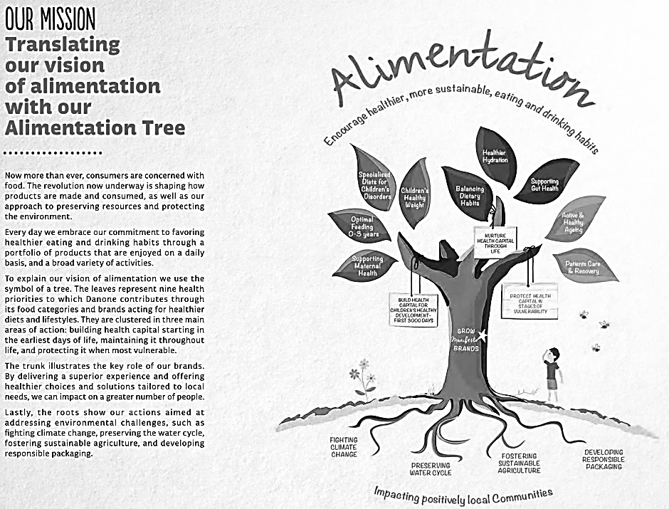

Source: Danone, *Danone 16: Welcome to the Alimentation Revolution—Integrated Report*, 9, accessed May 16, 2018, http://danone-danonecom-prod.s3.amazonaws.com/user_upload/Danone-Integrated-Report-Summary-2016.pdf.

Exhibit 1 (continued)

Material Aspects

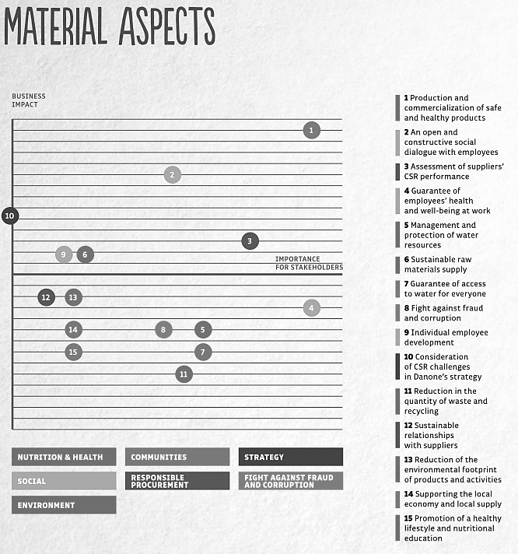

Source: Danone, *Danone 16: Welcome to the Alimentation Revolution—Integrated Report*, 12, accessed May 16, 2018, http://danone-danonecom-prod.s3.amazonaws.com/user_upload/Danone-Integrated-Report-Summary-2016.pdf.

Exhibit 1 (continued)

Healthier Future

|  |  |
| --- | --- |
|  |  |
|  |  |

Source: “DANONE – Integrated Report 2016 – Unique Business Approach,” YouTube video, 1:21, posted by “Danone,” April 11, 2017, accessed May 16, 2018, <https://youtu.be/sivXgPVo67E>; “DANONE - Integrated Report 2016 – Better Health,” YouTube video, 1:56, posted by “Danone,” April 11, 2017, accessed May 16, 2018, <https://youtu.be/nFtVl5sl5y4>; “DANONE – Integrated Report 2016 – Better World,” YouTube video, 1:49, posted by “Danone,” April 11, 2017, accessed May 16, 2018, <https://youtu.be/ohznFnWCvZE>; “DANONE – Integrated Report 2016 – Better Lives,” YouTube video, 1:11, posted by “Danone,” April 11, 2017, accessed May 16, 2018, <https://youtu.be/jcQ1KFQugtM>; Danone, *Danone 16: Welcome to the Alimentation Revolution—Integrated Report*, 13, accessed May 16, 2018, http://danone-danonecom-prod.s3.amazonaws.com/user_upload/Danone-Integrated-Report-Summary-2016.pdf.

Exhibit 1 (continued)

Unique Business Approach

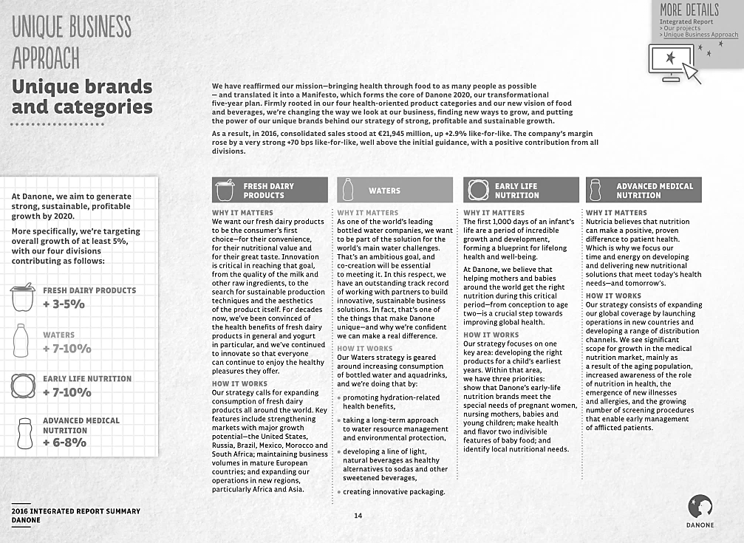

Source: Danone, *Danone 16: Welcome to the Alimentation Revolution—Integrated Report*, 14, accessed May 16, 2018, http://danone-danonecom-prod.s3.amazonaws.com/user_upload/Danone-Integrated-Report-Summary-2016.pdf.

Exhibit 1 (continued)

Unique Business Approach—Key Performance Indicators

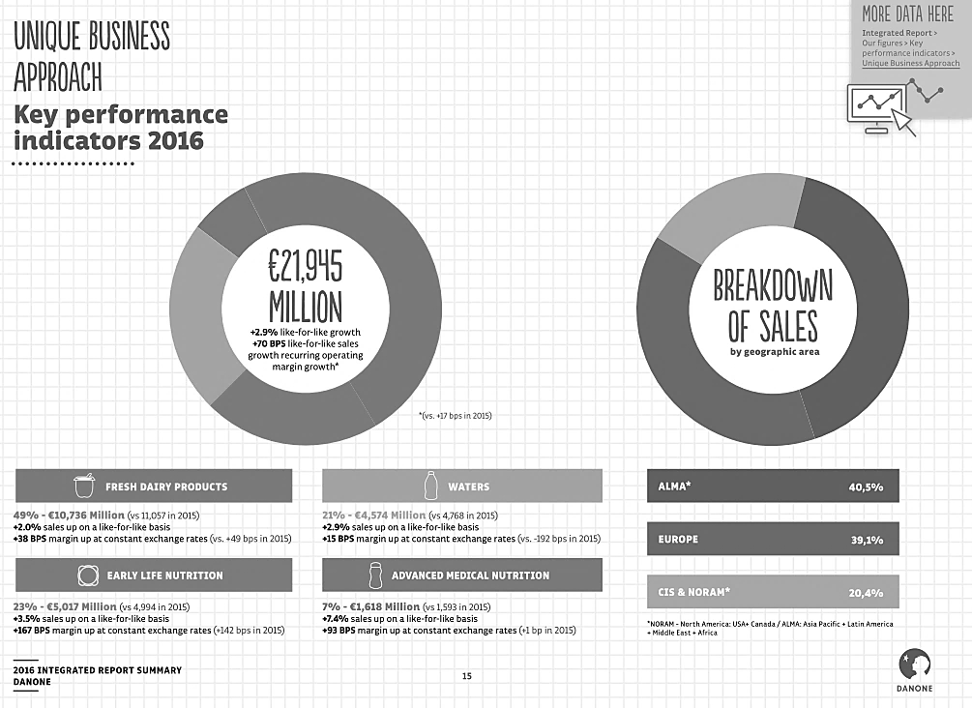

Source: Danone, *Danone 16: Welcome to the Alimentation Revolution—Integrated Report*, 15, accessed May 16, 2018, http://danone-danonecom-prod.s3.amazonaws.com/user_upload/Danone-Integrated-Report-Summary-2016.pdf.

Exhibit 1 (continued)

Better World—Nature Dashboard

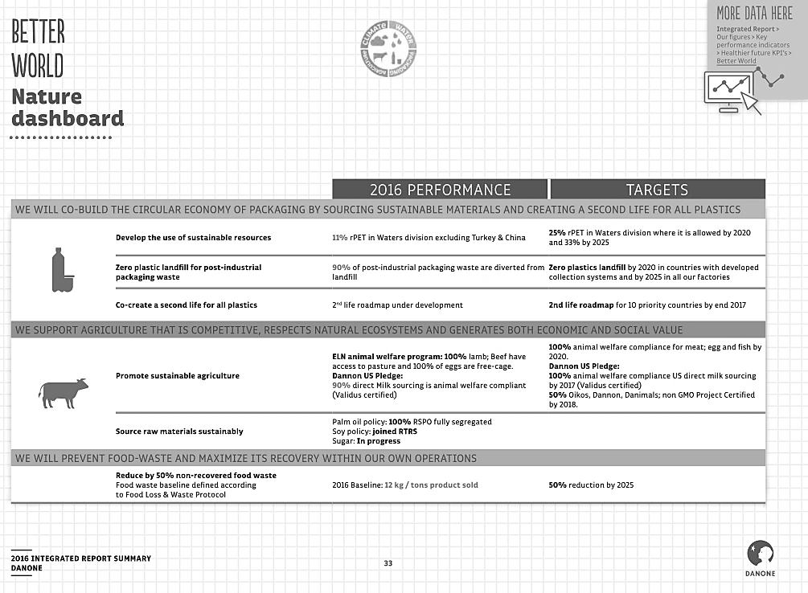

Source: Danone, *Danone 16: Welcome to the Alimentation Revolution—Integrated Report*, 33, accessed May 16, 2018, http://danone-danonecom-prod.s3.amazonaws.com/user_upload/Danone-Integrated-Report-Summary-2016.pdf.

Exhibit 2: Danone’s Manifesto

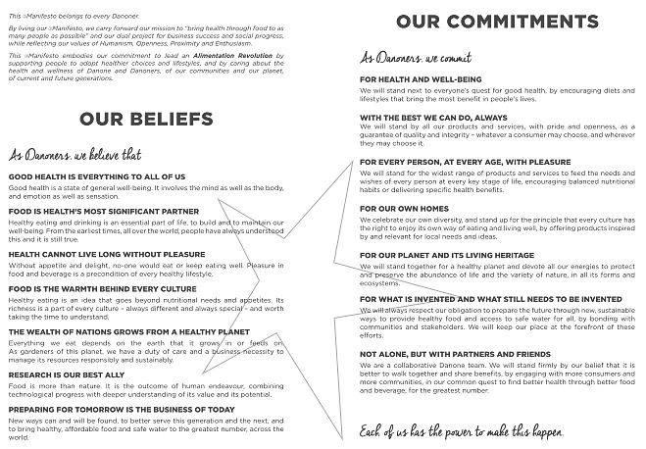

Source: Company files.

1. “Danone Manifesto,” Danone, accessed April 17, 2018, www.danone.com/en/for-all/our-mission-in-action/our-commitment/our-manifesto/.
2. Efreeburg, “Danone Joins Multinational Advisory Council,” B the Change (blog), January 7, 2016, accessed April 17, 2018, www.bcorporation.net/blog/danone-joins-multinational-advisory-council.
3. “What Are B Corps?,” B Corporation, accessed April 17, 2017, www.bcorporation.net/what-are-b-corps.
4. “Performance Requirements,” B Corporation, accessed April 17, 2018, www.bcorporation.net/become-a-b-corp/how-to-become-a-b-corp/performance-requirements.
5. “Assess Your Impact,” B Impact Assessment, accessed April 17, 2018, http://bimpactassessment.net/how-it-works/assess-your-impact.
6. Dennis Tobin, “The Evolution of the Corporation: The Public Benefit Corporation,” Blaney McMurty Publications, August 28, 2013, accessed April 17, 2018, www.blaney.com/articles/the-evolution-of-the-corporation-the-public-benefit-corporation.
7. Beth Kowitt, “This Dairy Company Says Its Business Model Is the Future of Corporate America,” *Fortune*, April 25, 2017, accessed April 17, 2018, http://fortune.com/2017/04/25/danone-white-wave-benefit-corporation/; “Our Ambition: Toward B Corp Certification as a Mark of Trust,” Danone, accessed April 17, 2018, http://iar2017.danone.com/vision-and-ambition/b-corp-global-ambition/?L=.
8. “Our Ambition: Toward B Corp Certification as a Mark of Trust,” Danone, accessed April 17, 2018, http://iar2017.danone.com/vision-and-ambition/b-corp-global-ambition/?L=.
9. “The Sustainable Development Agenda,” United Nations, accessed April 18, 2018, www.un.org/sustainabledevelopment/development-agenda/.
10. “Our Contribution to the UN’s Sustainable Development Goals,” Danone, accessed April 17, 2018, http://iar2017.danone.com/vision-and-ambition/contribution-to-un-sdgs/?L=.
11. Ibid.
12. € = EUR = euro; €0.7628 = WS$1.00 in June 2013.
13. “Danone Successfully Issues a Pioneer €300m Social Bond Continuing to Invest for Sustainable Value for All,” News release, West GlobeNewswire, March 19, 2018, accessed April 17, 2018, https://globenewswire.com/news-release/2018/03/19/1442256/0/en/DANONE-Danone-successfully-issues-a-pioneer-300m-social-bond-continuing-to-invest-for-sustainable-value-for-all.html.